David’s Lecture Repository Solution
How to Setup David’s lecture repository solution for local development
To begin development, you will want/need 3 things:
1. XAMPP (or similar web development software): http://sourceforge.net/projects/xampp/ .
NOTE: You will be making use of XAMPP’s Apache and MySQL/phpmyadmin features
2. SVN software (such as Tortoise SVN): http://tortoisesvn.net/downloads
3. A code/text editor such as Notepad++.
NOTE: You will probably want the capability to see a directory tree, so if using Notepad++, download the “Explorer plugin” by Jens Lorenz (http://sourceforge.net/projects/npp-plugins/ ).
Please note: The following section describes how to install XAMPP. The other aforementioned software is relatively easy to download/install, so they do not have a section of their own in this guide.
Installing/Running XAMPP
1. Begin installing XAMPP. I recommend installing directly to the root of your hard drive. Otherwise, you may encounter issues (I had issues with Apache when I installed XAMPP to a place other than the root)
2. When installing XAMPP, you do not need to “install services”, though I suppose you can if you want to.
3. Test XAMPP by using the Control Panel.exe . Click “start” next to Apache and MySQL. Now they should both have a green “running” display text that appears by each of them. (if you run into problems getting the “running” text to display, it may be because of other programs running on your computer such as Skype, McAfee, etc. )
4. Once you have the green “running” text, you’re good to go as far as XAMPP setup goes.

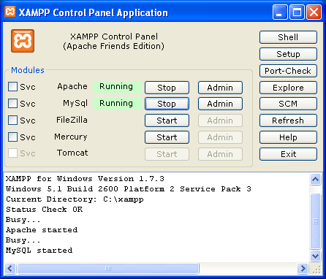
Good to go!
Editing David’s lecture repository solution
1. David’s solution is—like anything else on the computer—just a collection of files! The working solution is currently hosted on a Google Project page. If you intend to use TortoiseSVN (or similar software) in conjunction with David’s solution, he will have to grant you “ownership” to the page.
2. After you have been made an owner, go to your XAAMP install directory and navigate to the “htdocs” folder. (on my computer, this is C:\xampp\htdocs). Create a folder, and give it some arbitrary name.
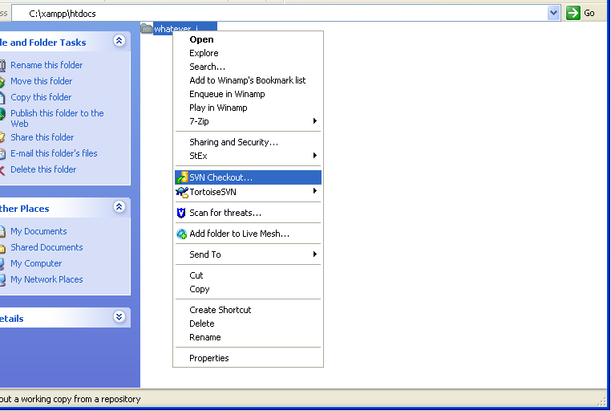
3. Now right-click that folder and go to “SVN checkout”. Paste the following URL into the top input field: https://homerweb.googlecode.com/svn/trunk/ .
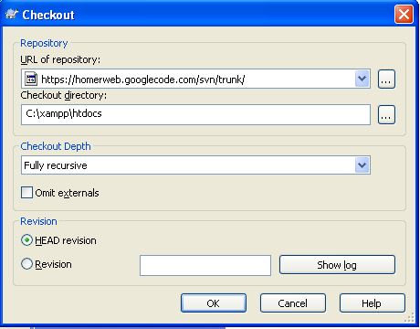
NOTE: This URL was retrieved from the homerweb project page: http://code.google.com/p/homerweb/source/checkout)
4. Go through the appropriate screens until your computer downloads the files from the repository. I believe that your folder will automatically be renamed to “homerweb”. If not, change it to that. Within your homerweb folder are all of the files used for David’s Lecture Repository Solution. You can now view and edit the files for the solution!
NOTE: To upload files back into the Google project page, right-click on the homerweb folder and click “commit”. However, you will probably want to click “update” before you do this in case someone else has committed new code since the last time you “updated” your code.
Viewing a local copy of the solution
1. Open XAMPP, and click start by “Apache” and “MySql”.
2. Open an internet browser and go to http://localhost/homerweb . You should now be viewing the “Chicago Boards Review” page.
Setting up the David’s Lecture Repository Solutions MySql tables for the 1st time
The phpMyAdmin interface within XAMPP accommodates for various ways of editing the SQL tables. Because David’s Lecture Repository Solution contains some pre-made SQL files, we are going to want to just paste those into the appropriate SQL fields on the website in order to initially establish the tables.
1. There should be a “createTables.sql” file within the root of your homerweb folder. Open it in a text-editor and copy all the text.
2. Then navigate to “SQL” tab on the http://localhost/phpmyadmin/ site. Paste the text in there and click “go”.
3. On the far left of the screen, you should see that a “cs4911” table got created. Click on it.
4. Now that you are within the cs4911 table, click on the SQL tab at the top, and you’ll be brought to another place to insert SQL text.
5. This time we want to copy the text from the “createTestData.sql” file within the root of your homerweb folder. Once you paste it in there, click “go”.
6. You’re done!
NOTE: If you modify one of the aforementioned SQL files, this is the same process you can use to re-insert them into the quasi-live tables stored on http://localhost/phpmyadmin/ . Alternatively, you can just edit SQL directly within the phpMyAdmin interface.

